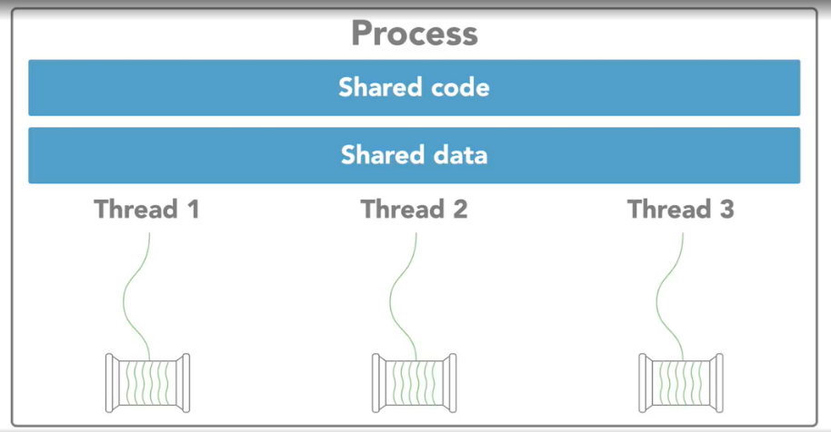
Process
Includes code, data, and state information
Independent instance of a running program
Separate address space
Thread
Independent path of execution
Subset of a process
Operating system schedules threads for execution
Inter-Process Communication (IPC)
Sockets and pipes
Shared memory
Remote procedure calls

Threads vs. Processes
Threads are "lightweight" - require less overhead to create and terminate
Operating system can switch between threads faster than processes

